Information Systems III (Module B) Test 1 – Memorandum

Question 1
1.1
1 M

DINNER
Served at

ENTREE

GUEST
DIN_GUEST
INV_GUEST
(1,1) (1,N)
1 M
(1,N) (1,1)

M O(1,1)

M 1 1(0,N)
(1,N) (1,1)1(10,30)

M(1,1)

INVITATION
(20)

  - A single-valued attribute is an attribute that can only have a single value. E.g. ID Number. A simple attribute cannot be subdivided to yield additional attributes. E.g. Age. A single valued attribute is not necessarily a simple attribute. E.g. An ID Number is single-valued but composite. (5)

  - A composite attribute is an attribute that can be further subdivided to yield additional attributes. E.g. ID Number, Yields DOB etc. (3)

  - A derived attribute need to physically be stored in database, instead it is derived using an algorithm. E.g. Total (3)

  - A weak entity is one that meets two conditions: It must be existence-dependent and it has a primary key that is partially or totally derived from the parent entity in the relationship. (5)

has

EMPLOYEE

DEPENDENT
1.6

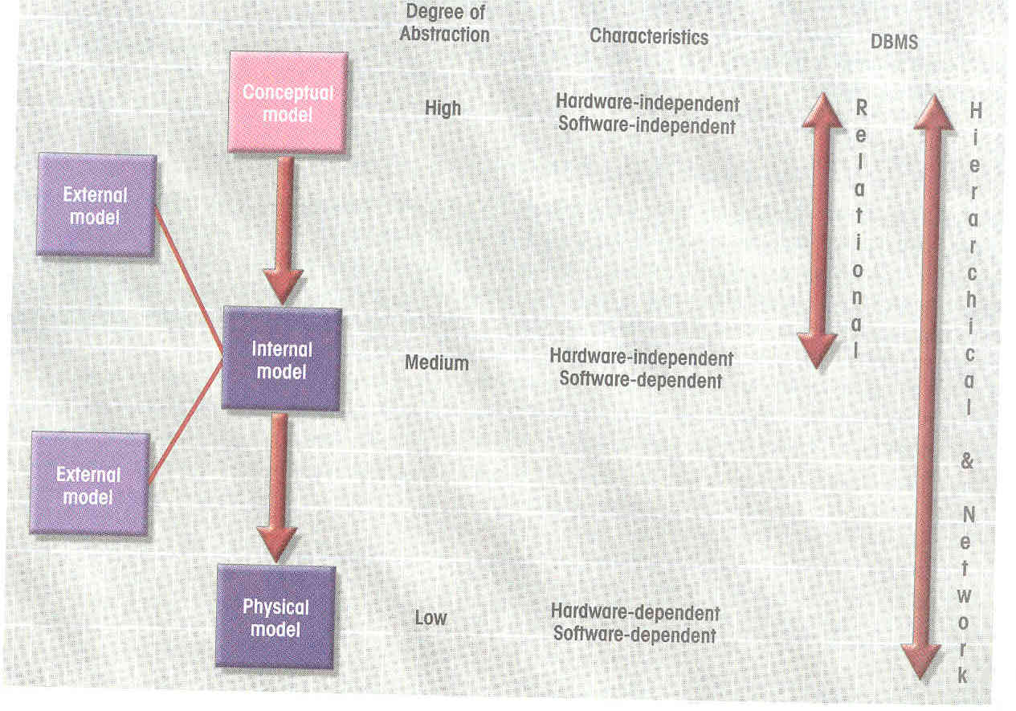
Question 2

2.1 Create table EMP (
EMPNUM NUMBER (3),
EMPTITLE VARCHAR(4),
EMPINIT VARCHAR(3),
EMPSURNAME VARCHAR(20),
EMPEXTENSION NUMBER(4));

  - INSERT INTO EMP
SELECT * FROM EMPLOYEE;

  - UPDATE EMP
SET PACKCOST = 2.15 WHERE
PACKNAME = ‘Words & More’;

  - SELECT E.EMPNUM, EMPTITLE, SURNAME, LOCATION, C.COMPID, PROCTYPE, MFGNAME
FROM EMPLOYEE E, PC, COMPUTER C
WHERE E.EMPNUM = PC.EMPNUM AND PC.COMPID = C.COMPID
ODER BY SURNAME;

  - SELECT E.EMPNUM, EMPSURNAME, PACKCOST
FROM EMPLOYEE E, PC, SOFTWARE S, PACKAGE P
WHERE E.EMPNUM = PC.EMPNUM AND PC.TAGNUM = S.TAGNUM AND S.PACKID = P.PACKID AND PACKCOST > 400;

  - SELECT E.EMPNUM, EMPTITLE, EMPINITIALS, EMPSURNAME
FROM EMPLOYEE E, PC, COMPUTER C, PACKAGE P
WHERE E.EMPNUM = PC.EMPNUM AND PC.COMPID = C.COMPID AND PROCTYPE = ‘486SX’;

Question 3

3.1 Transaction is a logical unit of work that must be completed or the transaction is aborted (2)

3.2.1
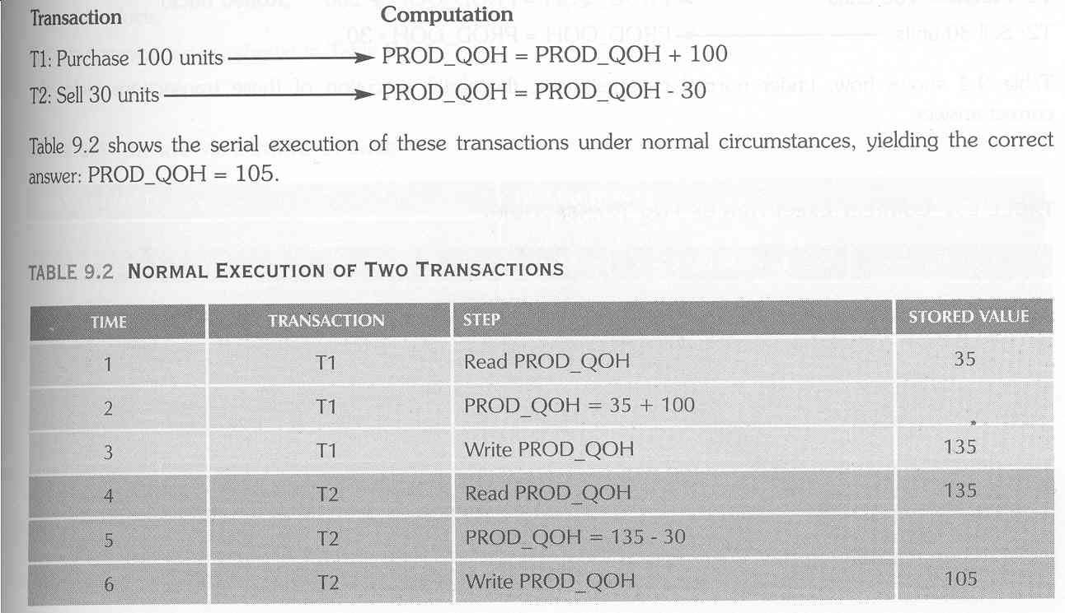
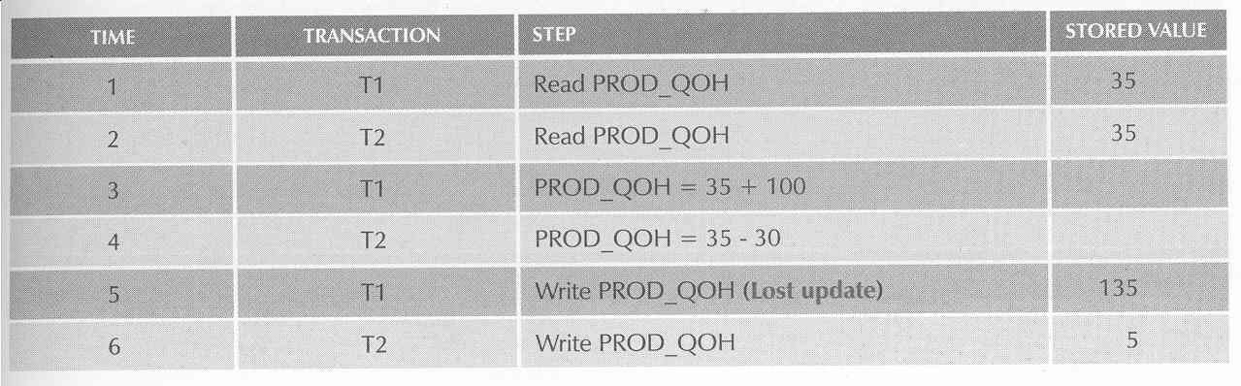
(6)
3.2.2

The same example as above. T1 has ROLLBACK added.

T1 Read PROD_QOH 35
T1 PROD_QOH = 35 + 100
T1 WRITE PROD_QOH 135
T2 READ PROD_QOH (Read Uncommitted data) 135
T2 PROD_QOH = 135 – 30
T1 **ROLLBACK**
T2 WRITE PROD_QOH 105
(6)

3.2.3
ATOMICITY – Requires that all operations of a transaction be completed, if not the transaction is aborted.
DURABILITY – Indicates the permanence of the database’s consistent state.
SERIALIZABILITY – Describes the result of the concurrent execution of several transactions.
ISOLATION – Means that the data used during the execution of a transaction cannot be used by a second transaction until the first one is completed.
3.3
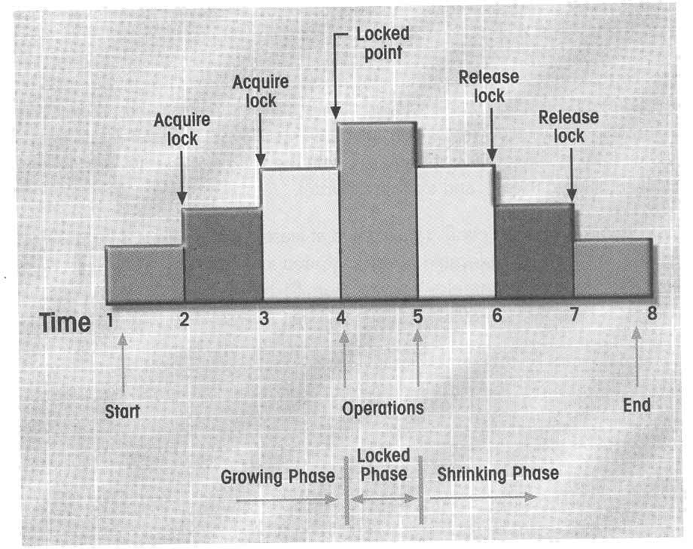(8)

  - i) Transaction operations do not immediately update the physical database.
ii) Only the transaction log is updated.
iii) The database is physically updated only after the transaction reaches its COMMIT point
iv) When transaction aborts before COMMIT point, no changes need to be made.
v) Identify the last checkpoint in the transaction log.
vi) For a transaction that started and is COMMITTED before the last checkpoint, nothing needed to be done.
vii) For a transaction that performed a COMMIT operation after the last checkpoint, the DBMS uses the transaction log records to redo the transaction and to update the database, using the after values in the transaction log.
viii) For any transaction with a ROLLBACK operation after the last checkpoint or that was left active (with neither a COMMIT nor a ROLLBACK) before the failure occurred, nothing needs to be done.
(6)

